|  |
| --- |
| Serial No: |
| **2nd Mid Term Exam**  **Spring Semester 2020** |
| **Max Time: 2 Hours** |
| **Max Marks: 50**  **Exam Weight (Out of 100). 10** |
|  |

|  |
| --- |
| **CS-217 OOP** |
| Monday, June 01, 2020 |
| **Course Instructor** |
| Dr. Danish Shehzad, Dr. Irfan ul Haq,  Miss. Zain Iqbal, Mr. Muhammad Haris,  Mr. Muhammad Ali |

|  |
| --- |
| _____________________ . .  Roll No Section |

**Guidelines for Submission:**

1. You should submit only one PDF document.
2. Write your Roll No on start of each answer.
3. Write the answers on paper and take picture. The figure/image can be pasted inside that document under the appropriate question.
4. You must submit your solution before due time via Google Classroom. Submissions submitted after the due time shall not be considered.
5. If you don’t finish every part of a question, don’t worry! You can still submit what you’ve done to get marks based on your efforts.
6. In case of copied or plagiarized solutions in exam Or If a student provided help to another student during exam both will be awarded **"F"** grade and it will affect the student CGPA.
7. **Viva** of any student can be conducted by the instructor after conducting an online exam **in case of any doubt.**
8. This document should be submitted through LMS Google Classroom. But in worst case, you can email it within the deadline.

|  |  |  |  |  |  |  |  |  |  |  |  |  |  |  |
| --- | --- | --- | --- | --- | --- | --- | --- | --- | --- | --- | --- | --- | --- | --- |
|  | **Q1** | **Q2** | **Q3** | **Q4** | **Q5** | **Q6** | **Q7** | **Q8** | **Q9** | **Q10** | **Q11** | **Q12** | **Q13** | Total |
| **Marks** | 3 | 3 | 3 | 3 | 3 | 3 | 3 | 3 | 3 | 3 | 3 | 5 | 12 | 50 |
| **Obtained** |  |  |  |  |  |  |  |  |  |  |  |  |  |  |

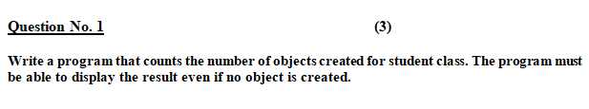

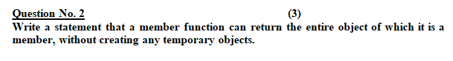

**Question No. 3 (3)**



**Question No. 4 (3)**

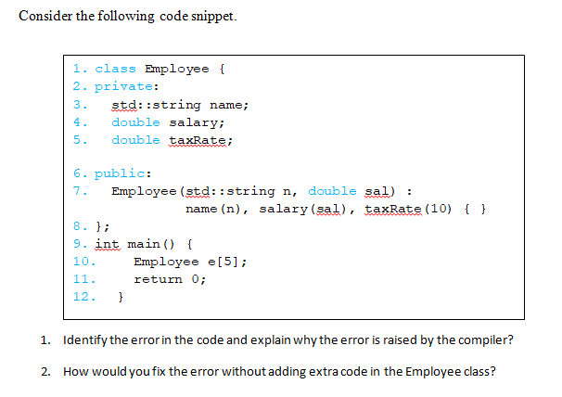

**Question No. 5 (3)**

**Real world objects in programmers view Exercise.**



**Map(write attributes and behaviors) at least three objects from the picture shown above.**

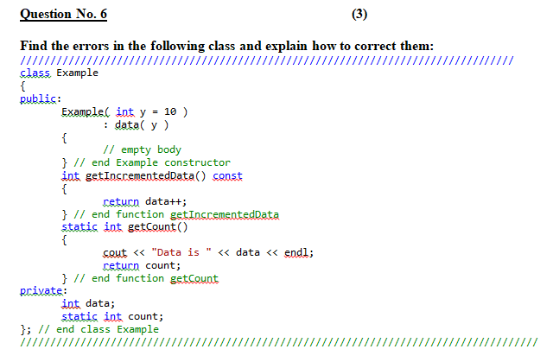

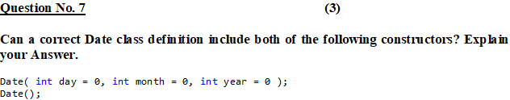

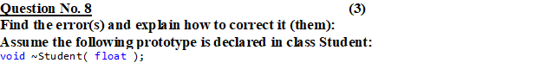



**Question No. 10 (3)**



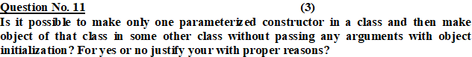

Yes, it is possible to make one prameterized constructor in class and then object of that classs in some other class in without passing any argmuments with object initialization.

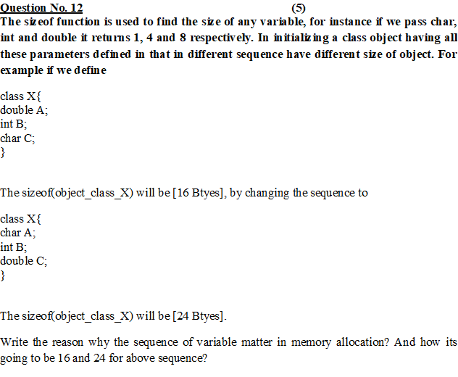

Memory allocation cycle through which ide allocates 4 byted to char in first example.and 8 bytes in 2nd example to complete cycle sequence

